PROJECT REPORT
AI QUIZ GENERATOR USING PYTHON

Submitted By
Name: CH.Rishitha
Roll Number: 23671A12A9
Department: INFORMATION TECHNOLOGY
College: J.B INSTITUTE OF ENGINEERING AND TECHNOLOGY

Submitted To
THINK CHAMP PVT LTD

Table of Contents
- Project Overview
- Project Objective
- Software Requirements
- Project Description
- Features of the Project
- Project Stucture
- Souce code
- Sample Output
- Advantages
- Limitations
- Future Enhancements
- Conclusion

1.Project Overview
The AI Quiz Generator is a Python-based mini project developed for conducting quizzes through the command-line interface. The application asks questions to users, accepts answers, validates them, calculates scores, and displays the final result automatically.
This project is useful for beginners to understand Python programming concepts such as loops, conditions, lists, dictionaries, file handling, randomization, and time functions.
The project behaves like a simple AI assistant by interacting with users through the terminal.

2.Project Objective
The main objectives of this project are:
- To develop an interactive quiz application.
- To ask multiple quiz questions.
- To validate user answers.
- To calculate scores automatically.
- To display the final result with grades.
- To save scores in a text file.

3.Software Requirements
Requirement | Description
Programming Language | Python
IDE/Editor | VS Code / PyCharm / IDLE
Platform | Windows/Linux
Python Version | Python 3.x

4.Project Description
The AI Quiz Generator works in the terminal or command prompt. The application displays quiz questions one by one with multiple-choice options. The user selects an answer by entering the option number.
The system checks whether the answer is correct or not and updates the score accordingly. A timer is used to limit the answering time for each question.
At the end of the quiz:
- Final score is displayed.
- Percentage is calculated.
- Grade is assigned.
- Score is saved into a text file.

5. Features of the Project
Mandatory Features
- Welcome Message
- Minimum 5 Quiz Questions
- User Answer Input
- Answer Validation
- Score Calculation
- Loop for Multiple Questions
- Final Result Display
Optional Features
- Timer
- Multiple Choice Questions
- Difficulty Levels
- Random Questions
- Colored Output
- Save Score in Text File

6.Project Structure
AI_Quiz_Generator/
- Quiz.py
- Questions.txt
- Scores.txt
- README.md

7. Source Code
import random
import time
# Quiz Questions
quiz_questions = [
{
"question": "What is Python?",
"options": ["A Snake", "Programming Language", "Game", "Browser"],
"answer": "Programming Language",
"difficulty": "Easy"
},
{
"question": "What does AI stand for?",
"options": ["Artificial Intelligence", "Automatic Input", "Advanced Internet", "None"],
"answer": "Artificial Intelligence",
"difficulty": "Easy"
},
{
"question": "Which keyword is used for loop in Python?",
"options": ["repeat", "for", "loop", "iterate"],
"answer": "for",
"difficulty": "Medium"
},
{
"question": "Which symbol is used for comments in Python?",
"options": ["//", "#", "/* */", "--"],
"answer": "#",
"difficulty": "Easy"
},
{
"question": "Which data type stores True or False?",
"options": ["int", "float", "bool", "string"],
"answer": "bool",
"difficulty": "Medium"
}
]
# Welcome Message
print("\n==============================")
print(" WELCOME TO AI QUIZ")
print("==============================\n")
name = input("Enter your name: ")
print("\nSelect Difficulty Level")
print("1. Easy")
print("2. Medium")
print("3. All")
choice = input("Enter choice: ")
selected_questions = []
if choice == "1":
selected_questions = [q for q in quiz_questions if q["difficulty"] == "Easy"]
elif choice == "2":
selected_questions = [q for q in quiz_questions if q["difficulty"] == "Medium"]
else:
selected_questions = quiz_questions
# Random Questions
random.shuffle(selected_questions)
score = 0
question_number = 1
for q in selected_questions:
print(f"\nQuestion {question_number}: {q['question']}")
options = q["options"]
random.shuffle(options)
for i in range(len(options)):
print(f"{i+1}. {options[i]}")
# Timer
start_time = time.time()
answer_input = input("Enter your answer: ")
end_time = time.time()
time_taken = end_time - start_time
if time_taken > 15:
print("Time Over! Question Skipped.")
continue
# Validate Input
if not answer_input.isdigit():
print("Invalid Input")
continue
answer_input = int(answer_input)
if answer_input < 1 or answer_input > len(options):
print("Invalid Option")
continue
user_answer = options[answer_input - 1]
# Check Answer
if user_answer.lower() == q["answer"].lower():
print("Correct Answer!")
score += 1
else:
print("Wrong Answer!")
print("Correct Answer is:", q["answer"])
question_number += 1
# Final Result
print("\n======================")
print(" QUIZ COMPLETED")
print("======================")
print(f"{name}, Your Final Score is: {score}/{len(selected_questions)}")
percentage = (score / len(selected_questions)) * 100
print("Percentage:", percentage, "%")
# Grade Calculation
if percentage >= 80:
print("Grade: A")
elif percentage >= 60:
print("Grade: B")
elif percentage >= 40:
print("Grade: C")
else:
print("Grade: Fail")
# Save Score to File
file = open("scores.txt", "a")
file.write(f"{name} - Score: {score}/{len(selected_questions)}\n")
file.close()
print("\nScore saved successfully in scores.txt")

8. Sample Output
Question Output
Question 1: What is Python?
1. A Snake
2. Game
3. Browser
4. Programming Language
Enter your answer: 4
Correct Answer!
Question 2: Which symbol is used for comments in Python?
1. #
2. /* */
3. --
4. //
Enter your answer: 1
Correct Answer!
Question 3: Which keyword is used for loop in Python?
1. loop
2. iterate
3. repeat
4. for
Enter your answer: 4
Correct Answer!

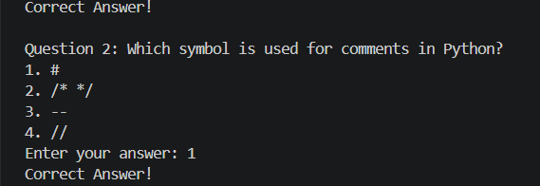
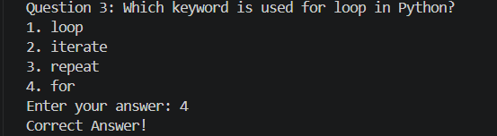
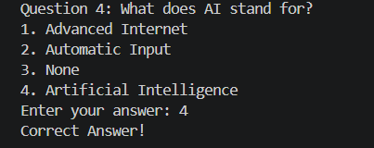

9. Advantages
- Easy to use
- Beginner-friendly project
- Improves Python programming skills
- Supports multiple-choice questions
- Calculates scores automatically
- Stores results in a file

10. Limitations
- Runs only in terminal/command prompt
- Limited number of questions
- No graphical user interface
- Questions are hardcoded

11. Future Enhancements
The project can be improved by adding:
- GUI using Tkinter
- Database connectivity
- Voice-based quiz system
- Online multiplayer quiz
- Leaderboard system
- AI-generated questions
- Web application support

12. Conclusion
The AI Quiz Generator is a simple and effective Python mini project that demonstrates important programming concepts such as loops, conditions, functions, file handling, and randomization.
This project helps beginners improve logical thinking and coding skills while creating an interactive quiz system. It can be extended further with advanced features and graphical interfaces.

